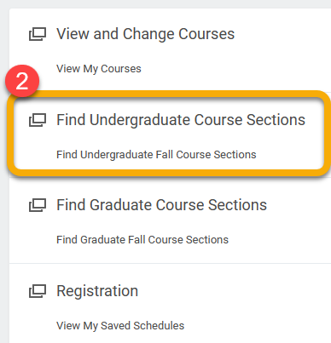
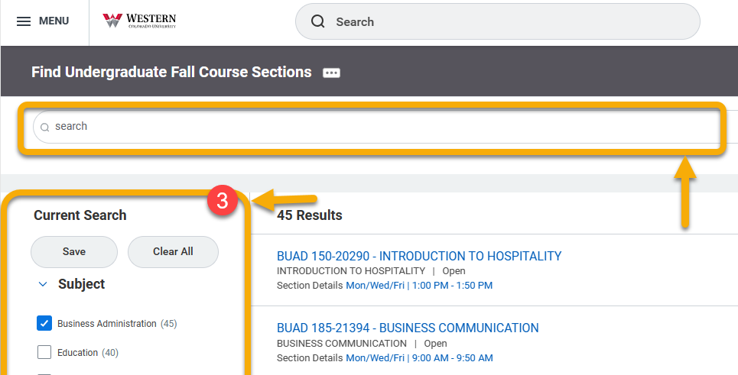
Instructions
- From your homepage, click Academics
- Click “Find Undergraduate/Graduate Course Sections”
- Search for a desired course using the left-hand menu or the search bar.
To prepare for registration,
1) Select course sections needed for the academic term,
2) Create a saved schedule and compile courses into the saved schedule,
3) Register from your saved schedule when the registration window opens

Saved schedules allow you to prepare a class schedule BEFORE registration opens. Use this reference to create your saved schedule.

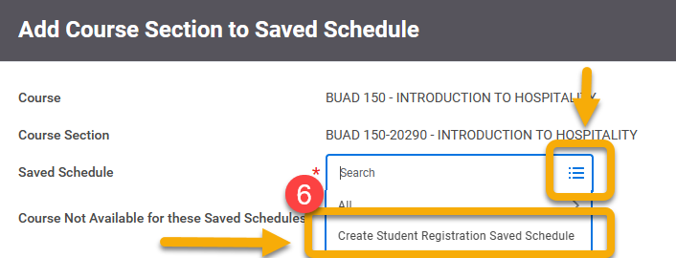
- Click the course section that best fits your schedule.
- To save the course to your saved schedule, click “Add to Saved Schedule”.
- Click the small icon to reveal a drop-down menu and click “Create Student Registration Saved Schedule”.
- Type a descriptive name for your new saved schedule.
- Click “Choose Times”, and click “OK”.

You save time and avoid mistakes by registering from a saved schedule.
Saved schedules allow you to prepare a class schedule BEFORE registration opens. Then, AFTER registration opens you can register all the course sections in your schedule as a group, instead of registering each course individually. Use this reference to create a saved schedule BEFORE the registration window opens.
At the end of this guide, you will find help answering common questions related to this process.

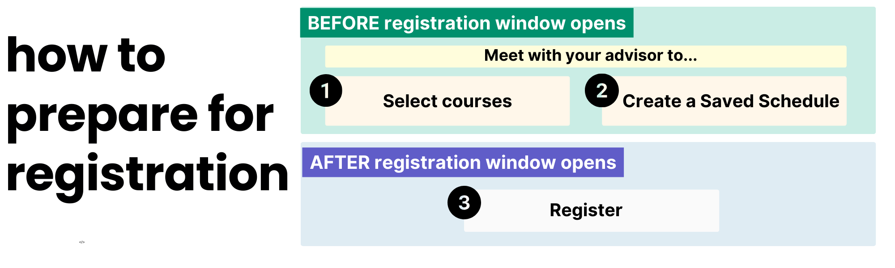

INSTRUCTIONS

- Click “Find Undergraduate/Graduate Course Sections” to view all available courses.

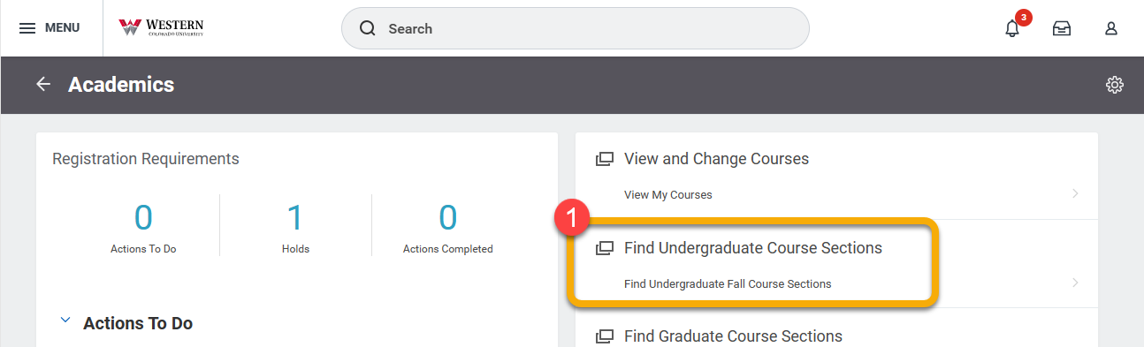

- Using the search criteria in the left-hand menu, customize your search. If you know the specific course you are looking for, type the course name in the search bar.
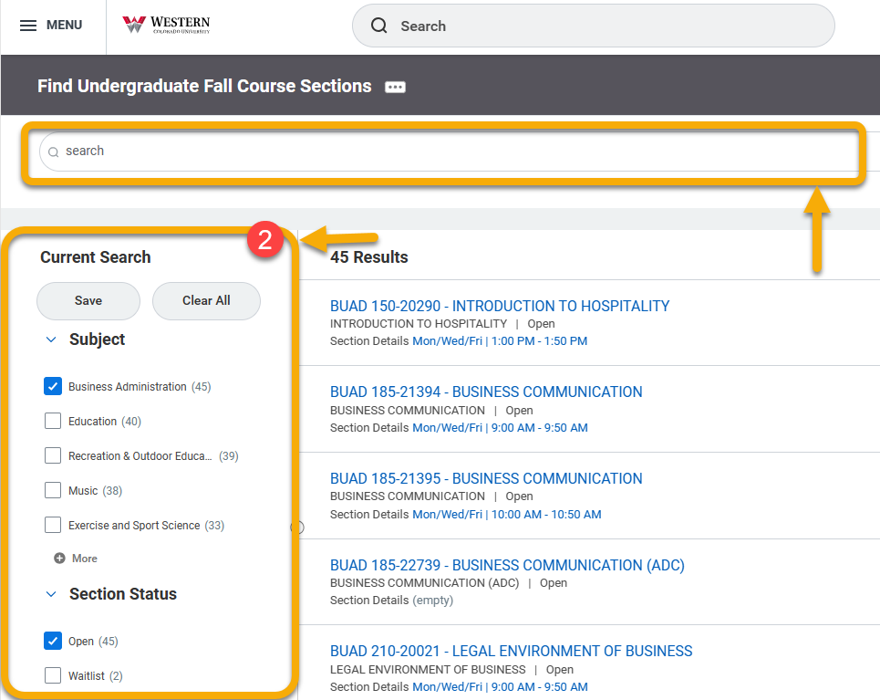

- To look at the details of a course, click the course title. TIP: When navigating in Workday, right click your mouse or touchpad to open pages in a new tab. You will navigate through your account with less interruption.

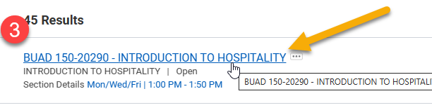

Review the additional details of the course. To save the course to your saved schedule, click “Add to Saved Schedule”.


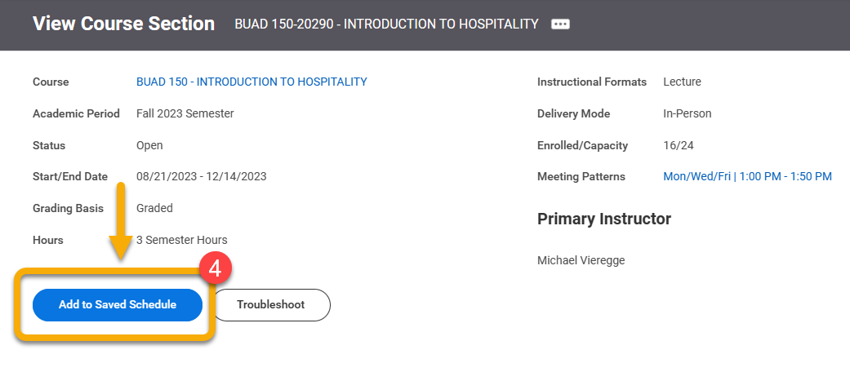
TIP: To confirm you meet course requirements and do not have schedule conflicts, click Troubleshoot.

Click the small icon in the blank field to create a new saved schedule or to display previously created saved schedules.

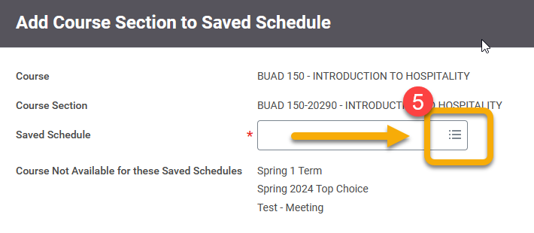

- To create a new saved schedule, click “Create Student Registration Saved Schedule” from the drop-down menu.
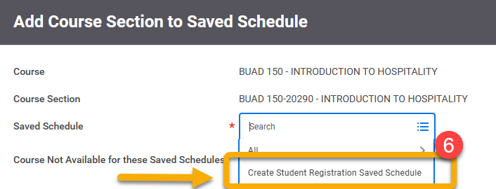

Type a descriptive name for your new saved schedule.

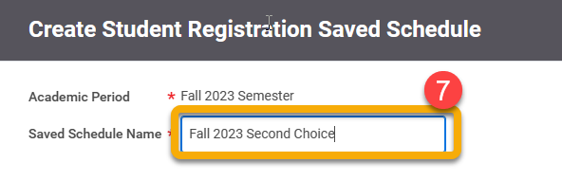



Click “Choose Times”

- Click “OK” to save. The selected course is now in your saved schedule.

- Click “Done” to exit the page and close the tab.

- On the Design Saved Schedule from Plan page, you have the option to see and print your saved schedule in calendar view or to make additional edits. Do not click the “Add Course” button. This takes you to the entire university catalog.
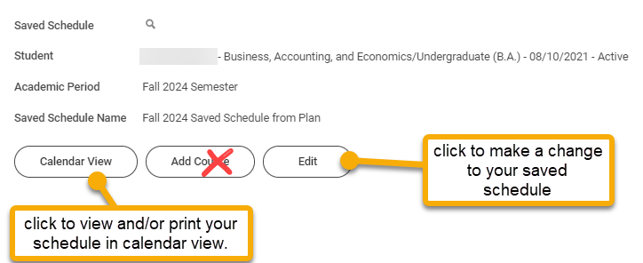

To add additional courses, return to step 1.

COMMON QUESTIONS
Problem | Possible Solution
What is the error message when I try to add a course to a saved schedule? | You may receive an error message when trying to add a course to your saved schedule. Sometimes, this may occur when you do not meet the course prerequisite, there is a schedule conflict in your schedule, you have an account hold, or the class is full.  To best understand your error message, return to the “View Course Section” page of the course you are interested in adding. Instead of clicking “Add to Saved Schedule”, click Troubleshoot.  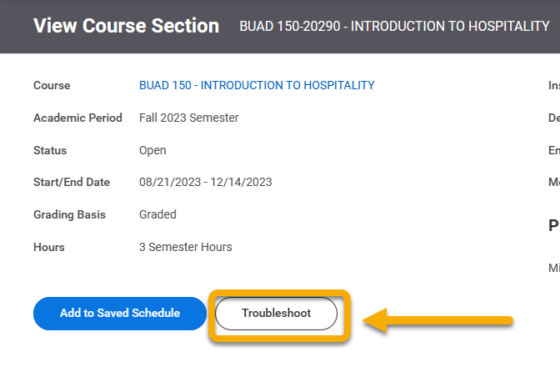  The Troubleshoot Registration page outlines the criteria required to register and whether you meet the criteria. In this example, the student already has another course in the saved schedule that presents a time conflict.  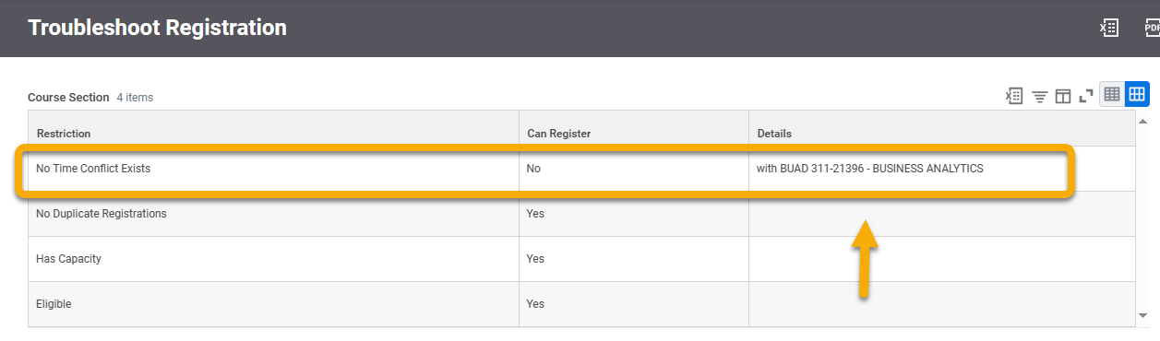
Why doesn’t the back button take me back to the previous webpage? |   Using your browser’s back button is not recommended in Workday, but it can be done.  Right-clicking links to open webpages in a new tab is most recommended. This will result in less interruption when navigating through course sections.  